Spatial Database ERD

Adam Schmitt, Elbio Iseas, Neil Goldstein, Sharon Foster

DBM/384

September 5, 2016

Devin Dickens

CREATE TABLE [dbo].[Customers]

(

[CustomerID] INT NOT NULL,

[CustomerFirstName] VARCHAR (30) NOT NULL,

[CustomerLastName] VARCHAR (30) NOT NULL,

[CustomerAddress] VARCHAR (50) NOT NULL,

[CustomerLat] [sys].[geometry] NOT NULL,

[CustomerLong] [sys].[geometry] NOT NULL,

PRIMARY KEY CLUSTERED ([CustomerID] ASC)

);

CREATE TABLE [dbo].[Stores]

(

[StoreID] INT NOT NULL,

[StoreName] VARCHAR (50) NOT NULL,

[StoreAddress] VARCHAR (50) NOT NULL,

[StoreLat] [sys].[geometry] NOT NULL,

[StoredLong] [sys].[geometry] NOT NULL,

PRIMARY KEY CLUSTERED ([StoreID] ASC)

);

CREATE TABLE [dbo].[PriceHistory]

(

[InventoryNum] INT NOT NULL,

[Description] VARCHAR (50) NOT NULL,

[DatePreviousPrice] DATE NULL,

[DateCurrentPrice] DATE NOT NULL,

[DateEndPrice] DATE NULL,

[InventoryPrice] DECIMAL (10, 2) NOT NULL,

PRIMARY KEY CLUSTERED ([InventoryNum] ASC)

);

CREATE TABLE [dbo].[Orders]

(

[OrderNum] INT NOT NULL,

[CustomerID] INT NOT NULL,

[InventoryNum] INT NOT NULL,

[OrderStore] INT NOT NULL,

[OrderQty] INT NOT NULL,

[OrderAmount] MONEY NOT NULL,

[OrderDate] DATE NOT NULL,

[OrderDistance] DECIMAL (18) NOT NULL,

CONSTRAINT [PK_Orders] PRIMARY KEY CLUSTERED ([OrderNum] ASC, [CustomerID] ASC, [InventoryNum] ASC, [OrderStore] ASC),

CONSTRAINT [FK_Orders_Customers] FOREIGN KEY ([CustomerID]) REFERENCES [dbo].[Customers] ([CustomerID]),

CONSTRAINT [FK_Orders_Stores] FOREIGN KEY ([OrderStore]) REFERENCES [dbo].[Stores] ([StoreID]),

CONSTRAINT [FK_Orders_PriceHistory] FOREIGN KEY ([InventoryNum]) REFERENCES [dbo].[PriceHistory] ([InventoryNum])

);

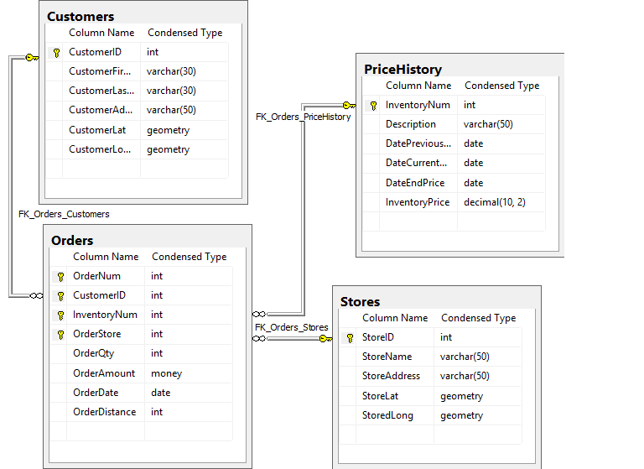

• How are the components stored in the database?   
Our locations are stored as Latitude and Longitude values for STORES, CUSTOMERS, and as a distance value for ORDERS.

• How does the component change the database?  
It creates a location value for all transactions that can be used to determine shipping demographics and other info.

• Does the addition of the component impact the level of normalization?  
Since we are breaking down location into individual values, no, it does not for customer locations, but technically, store locations could be spun into a separate table and a key could be defined to stand in place.